EXP.NO: 1 Web Page Creation using HTML
NAME : SURIYA T ROLL NO : 241501228
241501228

Online Donation & Charity Website

AIM
To create an Online Donation & Charity Website web page that embeds a map with hotspots, frames, and links. The web page should be designed using HTML, incorporating embedded, external, and inline CSS for styling. This exercise aims to enhance understanding of integrating multimedia elements like maps, creating interactive hotspots, and organizing content using frames while applying different CSS techniques for styling.

ALGORITHM
1. Create the HTML structure with <!DOCTYPE html>, <html>, <head>, and <body> tags.
2. Link the external CSS file in the <head> section and include embedded CSS using <style>.
3. In the <body>, create header, navigation links, embedded map, hotspot image, and frames using iframes.
4. Use <map> and <area> tags to create hotspots linking to Donate and About pages.
5. Apply styling using external, embedded, and inline CSS.
6. Test the page for proper working of map, hotspots, frames, and links.

CODE

index.html
<!DOCTYPE html>
<html>
<head>
<title>Helping Hands Charity</title>

<link rel="stylesheet" href="style.css">

<style>
.highlight {
color: darkred;
font-weight: bold;
}
</style>
</head>

<body>

<header style="font-size:42px;">Helping Hands Charity</header> <!-- Inline CSS -->

<nav>
<a href="index.html">Home</a>
<a href="donate.html">Donate</a>
<a href="about.html">About Us</a>
</nav>

<div class="hero">
<h1>Give Hope. Save Lives.</h1>
<p class="highlight">Your small contribution can create a big impact in someone's life.</p>
</div>

<h2>📍 Our Location (Google Map)</h2>

<iframe
class="map-frame"
src="https://www.google.com/maps/embed?pb=!1m14!1m12!1m3!1d8836.606498198344!2d79.552795001451!3d11.570746285704194!2m3!1f0!2f0!3f0!3m2!1i1024!2i768!4f13.1!5e1!3m2!1sen!2sin!4v1770298508459!5m2!1sen!2sin"
width="600" height="450"
style="border:0;"
allowfullscreen=""
loading="lazy"
referrerpolicy="no-referrer-when-downgrade">

</iframe>

<h2>🖼️ Hotspot Image</h2>

<img src="images/hotspot map.png"
usemap="#charitymap"
width="600" height="450"
class="hotspot-img">

<map name="charitymap">
<area shape="rect" coords="50,50,200,200" href="donate.html" alt="Donate">
<area shape="circle" coords="400,150,80" href="about.html" alt="About">
</map>

<h2>📄 For More Information</h2>

<div class="frame-container">
<iframe src="donate.html" class="content-frame"></iframe>
<iframe src="about.html" class="content-frame"></iframe>
</div>

</body>
</html>

style.css
body {
margin: 0;
font-family: 'Segoe UI', Tahoma, Geneva, Verdana, sans-serif;
background: linear-gradient(to right, #e8f0fe, #ffffff);
}

header {
background: #0b3d91;
color: white;
padding: 22px;
text-align: center;
font-size: 32px;
letter-spacing: 2px;
}

nav {
background: #145da0;
padding: 12px;
text-align: center;
}

nav a {
color: white;
text-decoration: none;
margin: 18px;
font-size: 18px;
font-weight: bold;
}

nav a:hover {
color: #ffd54f;
}

.hero {
text-align: center;
padding: 35px;
background: #d6e6ff;
margin: 25px 60px;
border-radius: 12px;
}

h2 {
text-align: center;
color: #0b3d91;
margin-top: 25px;
}

.map-frame {
display: block;
margin: 20px auto;
width: 65%; /* Reduced width */
height: 250px; /* Reduced height */
border: 3px solid #145da0;
border-radius: 10px;
}

.hotspot-img {
display: block;
margin: 20px auto;
border: 3px solid #145da0;
border-radius: 10px;
}

.frame-container {
display: flex;
justify-content: center;
gap: 25px;
margin: 30px;
}

.content-frame {
width: 40%;
height: 260px;
border: 3px solid #145da0;
border-radius: 10px;
box-shadow: 0 0 10px #999;
}

OUTPUT
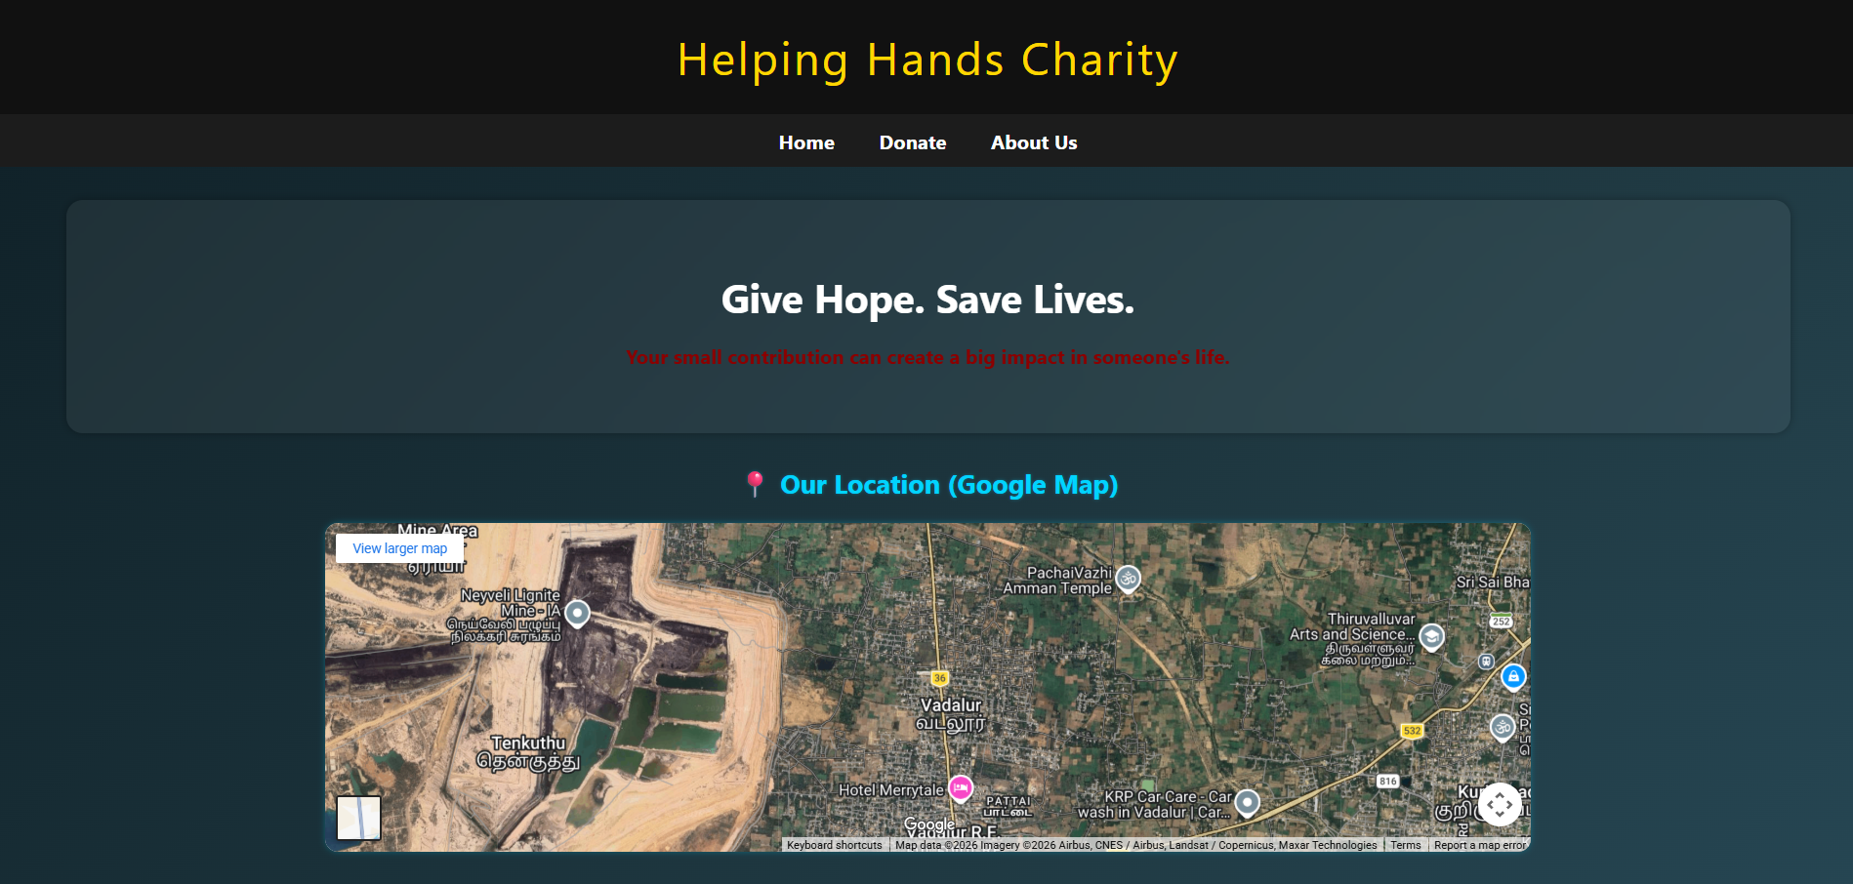
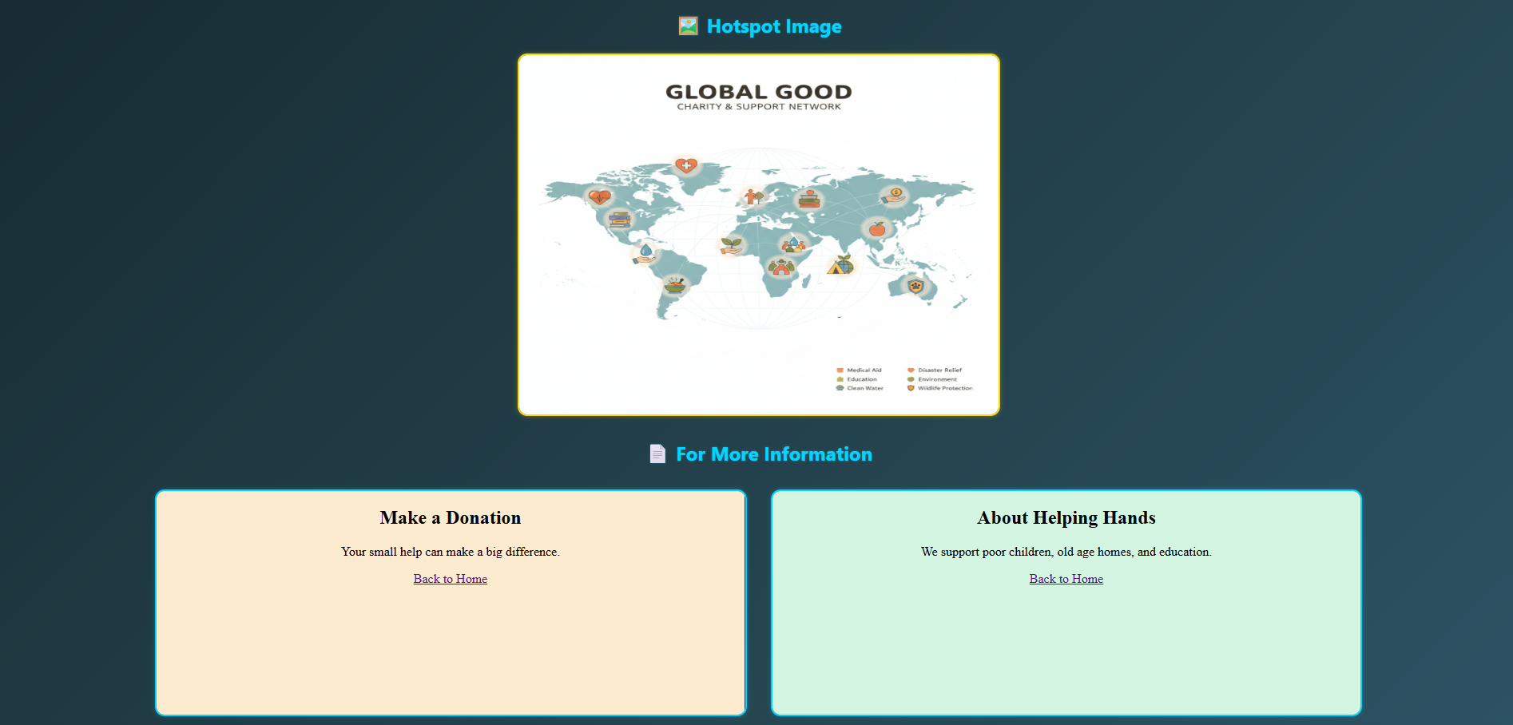
The homepage of the Online Donation & Charity Website is displayed with map, hotspots, frames, and links.

RESULT
Thus, the HTML page for the Online Donation & Charity Website is created successfully with an embedded Chennai map along with hotspot, frames, and links using inline, embedded, and external CSS.

